**Q1. To perform geometric transformations i.e., Translation, Scaling, Rotation on a given image.**

Code:

I1 = imread('cameraman.tif');

I1_ref = imref2d(size(I1));

T = [1 0 0; 0 1 0; 15 30 1];

[I2, I2_ref] = imwarp(I1, affine2d(T), 'OutputView', I1_ref);

T = [0.9 0 0; 0 0.8 0; 0 0 1];

[I3, I3_ref] = imwarp(I1, affine2d(T), 'OutputView', I1_ref);

x = pi/6;

T = [cos(x) sin(x) 0; -sin(x) cos(x) 0; 0 0 1];

[I4, I4_ref] = imwarp(I1, affine2d(T), 'OutputView', I1_ref);

figure;

subplot(2, 2, 1);

imshow(I1, I1_ref);

subplot(2, 2, 2);

imshow(I2, I2_ref);

subplot(2, 2, 3);

imshow(I3, I3_ref);

subplot(2, 2, 4);

imshow(I4, I4_ref);

Output:

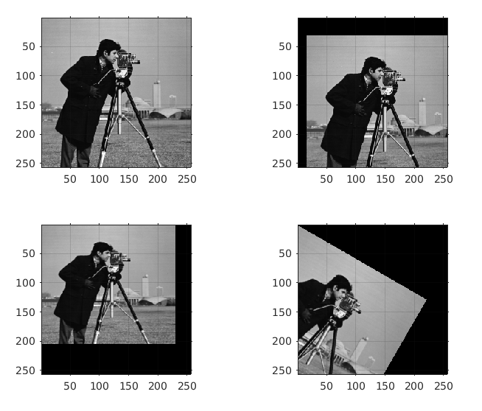

Q3. **Apply Weiner Filter to a given blurred image.**

Code:

I = imread('cameraman.tif');

PSF = fspecial('motion', 21, 11);

Idouble = im2double(I);

I1 = imfilter(Idouble, PSF, 'conv', 'circular');

subplot(1, 2, 1);

imshow(I1);

title('Blurred Image');

I2 = deconvwnr(I1, PSF);

subplot(1, 2, 2);

imshow(I2);

title('Restored Blurred Image');

Output:

